Threat Hunting in the Healthcare Sector using MITRE ATT&CK.

Prepared by: Biliaminu B. Salawu
Date: 11/11/2025

Project Overview
This project focuses on proactive threat hunting within the healthcare industry, leveraging the MITRE ATT&CK framework to identify and analyse Advanced Persistent Threat (APT) groups targeting the sector.
The objective was to:
- Identify healthcare-targeted APTs.
- Analyse their Tactics, Techniques, and Procedures (TTPs).
- Visualize the threat landscape using MITRE Navigator.
- Compare APTs to find common attack vectors.

Objectives
- Understand the MITRE ATT&CK framework and its application to real-world threat hunting.
- Research APTs targeting the healthcare sector using SOCRadar Labs.
- Map identified APTs to relevant TTPs in MITRE ATT&CK Navigator.
- Perform a comparative analysis to highlight overlapping attack patterns.

Tools & Resources
- SOCRadar Labs – For retrieving healthcare-specific APT threat intelligence.
- MITRE ATT&CK Navigator – For mapping APT TTPs.
- MITRE ATT&CK Framework – For structured adversary behaviour taxonomy.
- OSINT Research – To cross-check TTP details from open sources.

Project Steps
1. Understanding the MITRE ATT&CK Framework
  - Studied the MITRE ATT&CK framework structure:
  - Tactics – The why of an attack (e.g., Initial Access, Persistence, Defence Evasion).
  - Techniques – The how of an attack (e.g., phishing, credential dumping).
  - Procedures – Real-world implementations of techniques.

I conducted and examined a threat group APT (Advanced Persistent Groups) common to a particular region and sector, the way they carry out their threats/attack etc
Following is a screenshot of their tactics and techniques.

2. Research APTs Peculiar to the Sector
I Used SOCRadar Labs to identify APT groups targeting healthcare.
  - Found the following:

  - APT41 – China-based cyber-espionage group and has been in existence since 2012 and their notable behaviours include using a wide range of malware and tools to complete mission objectives

APT10 – Menu Pass are known to have acted in association with the Chinese Ministry of State Security's (MSS) Tianjin State Security Bureau and worked for the Huaying Haitai Science and Technology Development Company.

  - APT18 – Suspected threat group that has operated since at least 2009 and has targeted a range of industries, including technology, manufacturing, human rights groups, government, and medical.

  - Turla – also known as Shell Crew is a cyber espionage threat group that has been attributed to Russia's Federal Security Service (FSB). They have compromised victims in over 50 countries since at least 2004, spanning a range of industries including government, embassies, military, education, research and pharmaceutical companies.

  - Evilnum also known as TA4563 OR G0120 Joint worm is a financially motivated threat group that has been active since at least 2018 and they are common ATP threat to Albania and Canada Health & Social Assistance.

3. Highlight of the TTPs
Identifying key TTPs from MITRE:

APT41:
T1078 – Valid Accounts
T1059 – Command and Scripting Interpreter
T1027 – Obfuscated Files or Information

APT10 menuPass:
  - 1140: Phishing
  - T1078 – Valid Accounts

Evilrum
T1140 – Deobfuscate/decode file or password

Turla
  - T1566 – Phishing
  - T1078 – Valid Accounts
  - T1059 – Command and Scripting Interpreter
  - T1555 – Credential from stored password

4. Map APTs to TTPs using MITRE Navigator
I Created individual layers in MITRE Navigator for each APT.
  - Color-coded:
  - Red – Techniques confirmed in public reports.
  - Orange – Techniques suspected but unconfirmed.
  - Green – Techniques with existing detection measures.

I conducted and examined a threat group APT (Advanced Persistent Groups) common to a particular region and sector, the way they carry out their threats/attack etc
Following is a screenshot of their tactics and techniques.
APT41 threat Group.
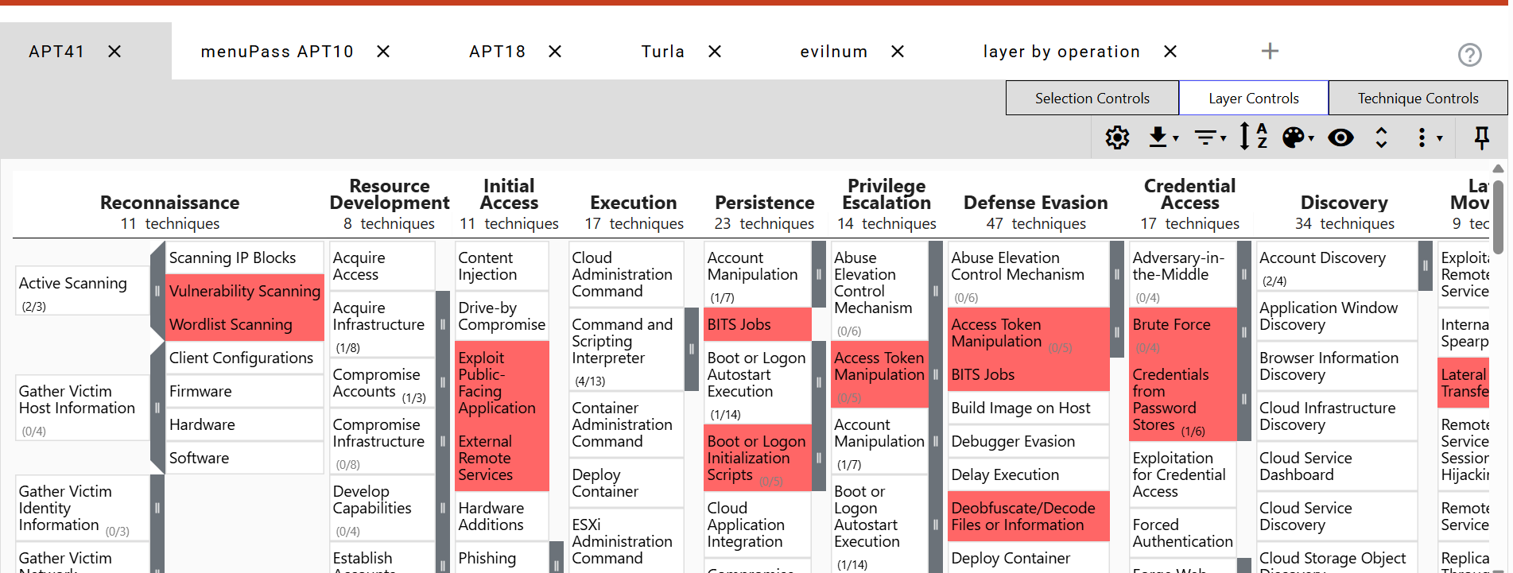

APT10 threat Group.

  - 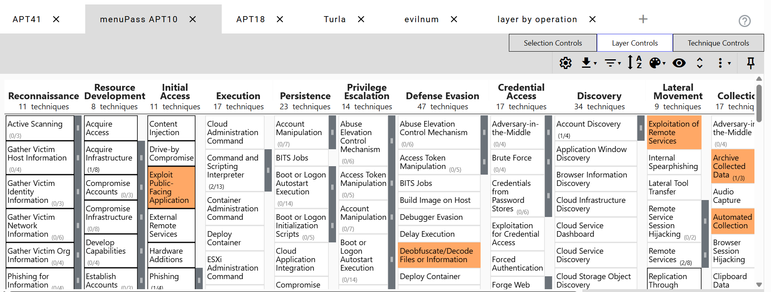

APT18 Threat Group.
  - 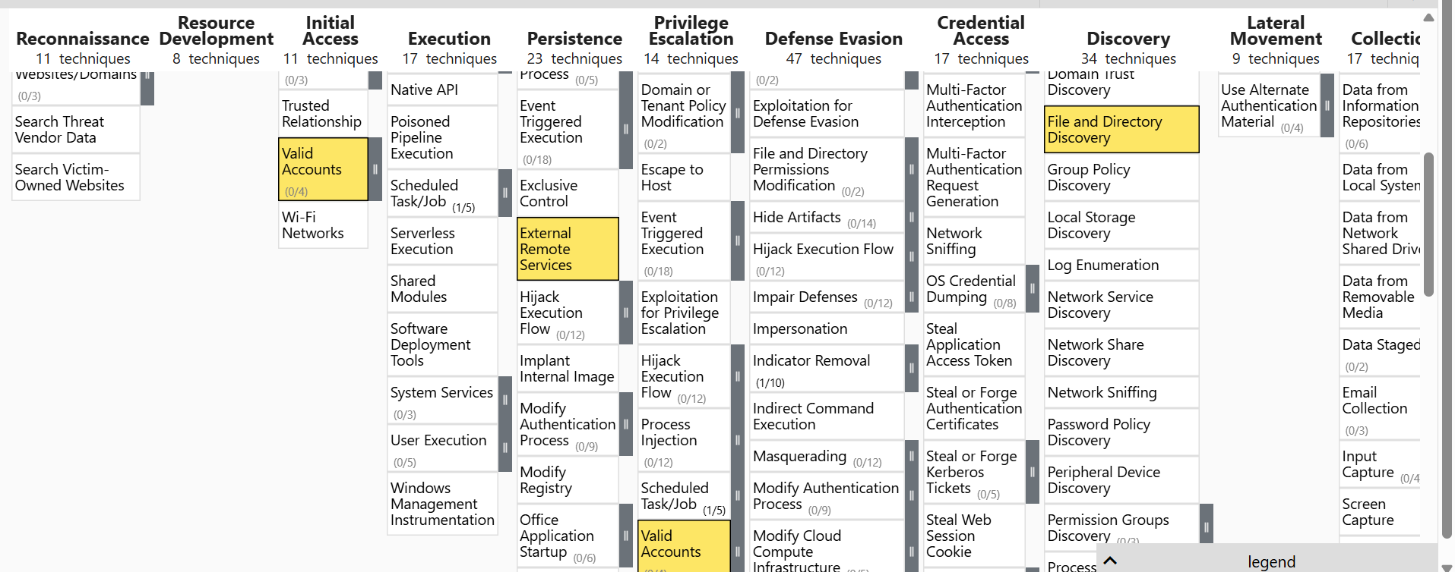

TURLA Threat Group.
  - 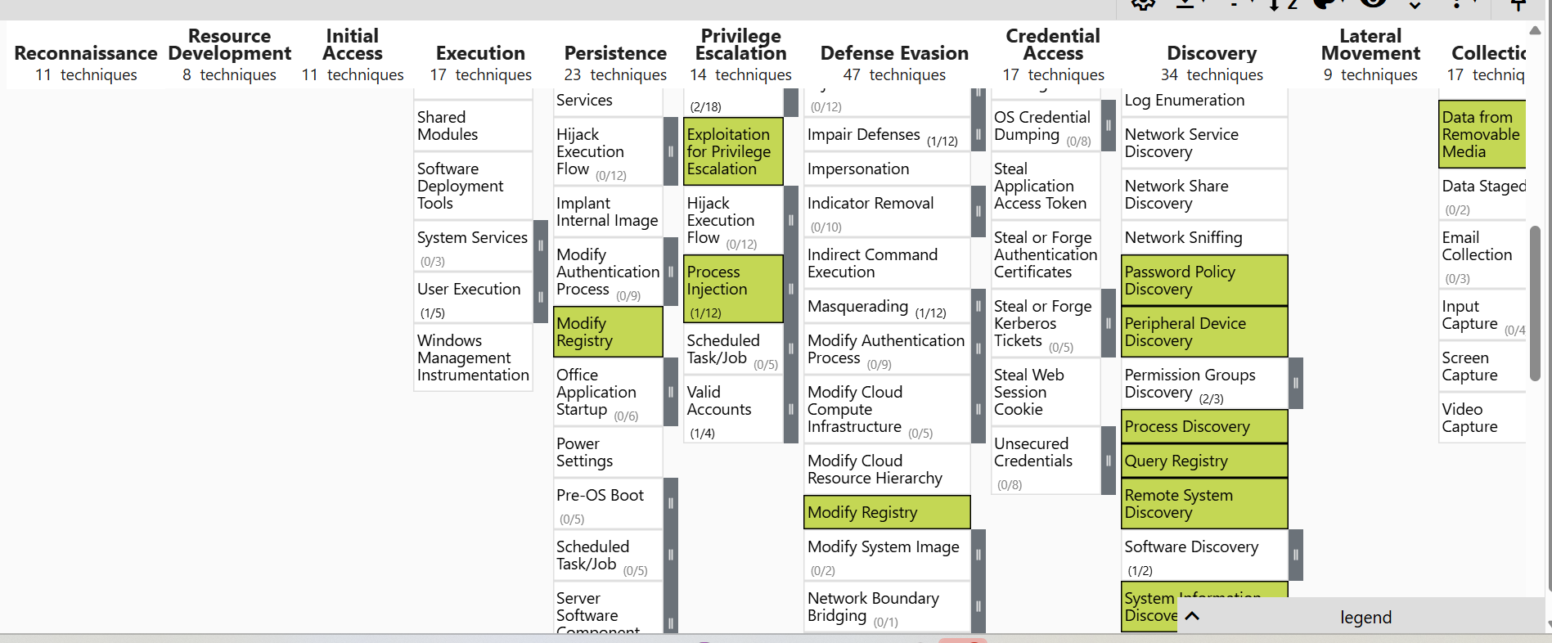

Evilrum Threat Group
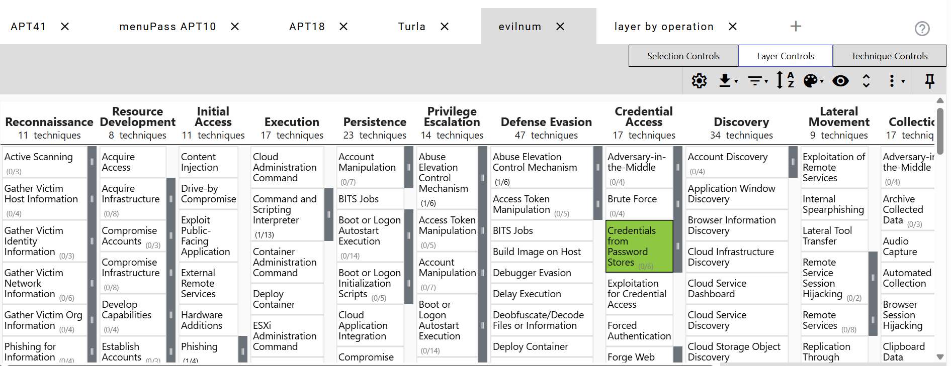

5. Compare the APTs
All five APT layers are imported into a combined Navigator view.

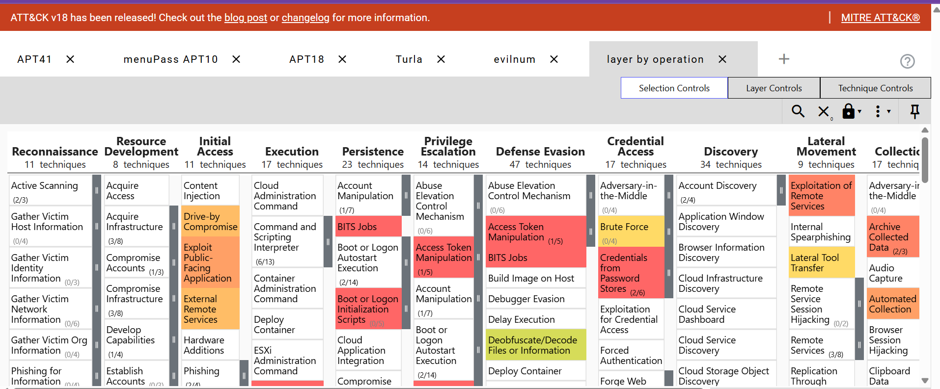
  - 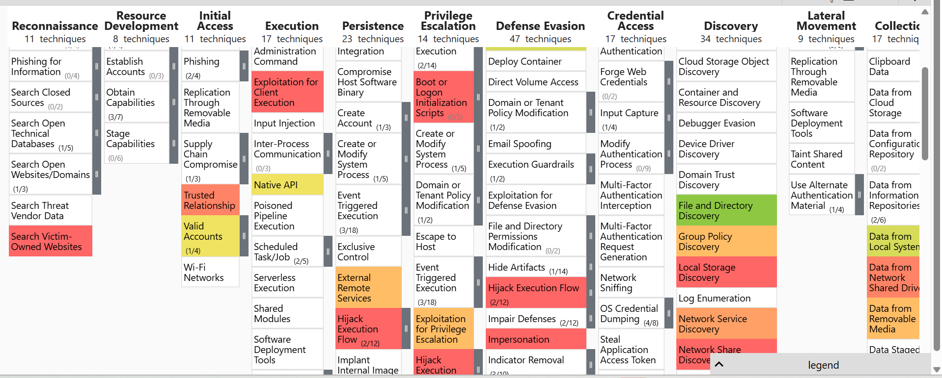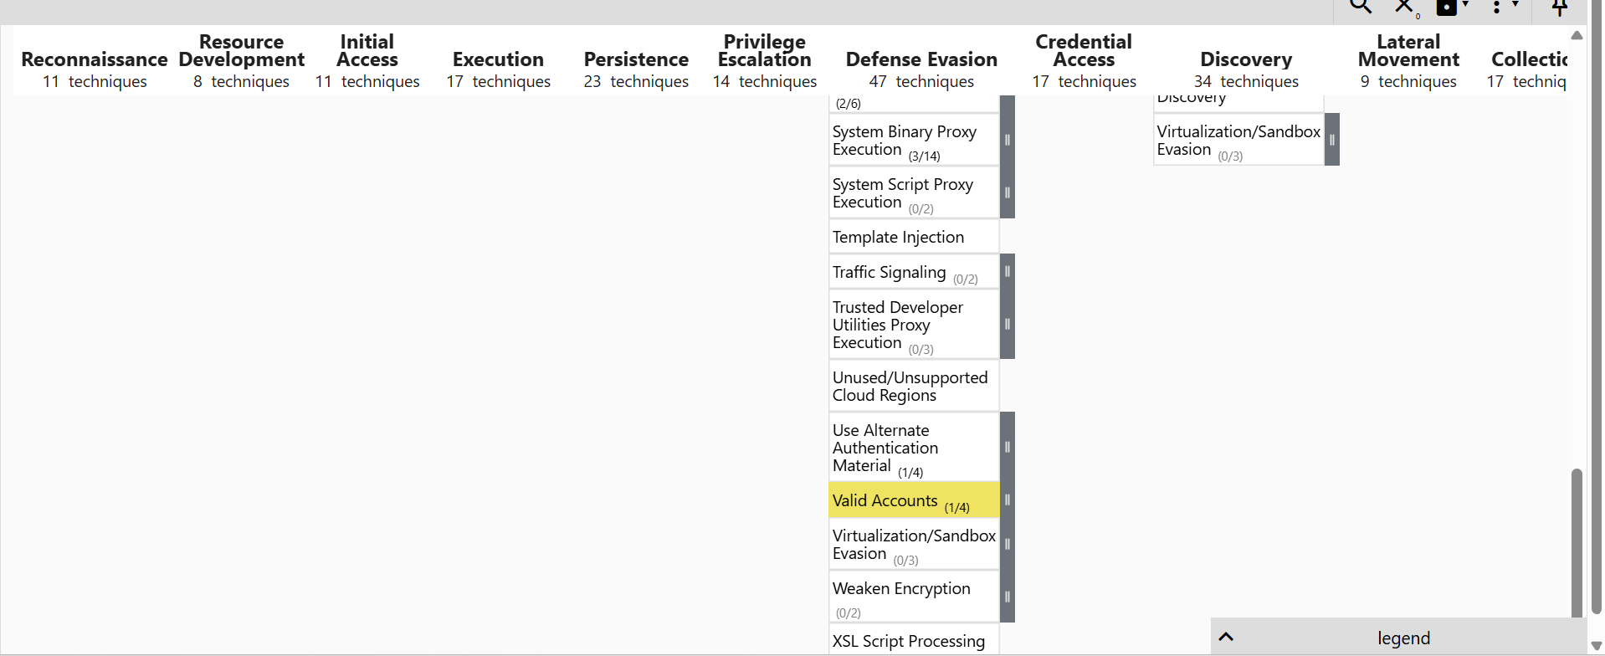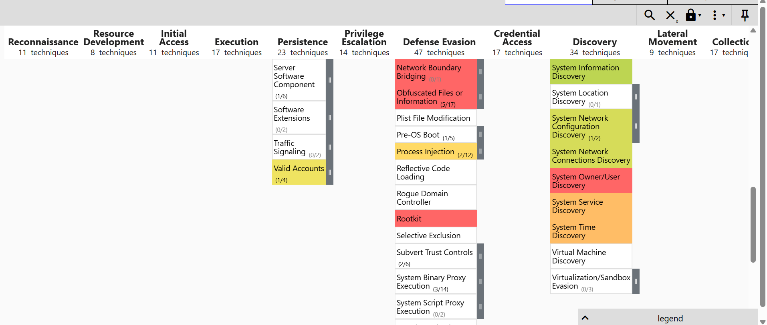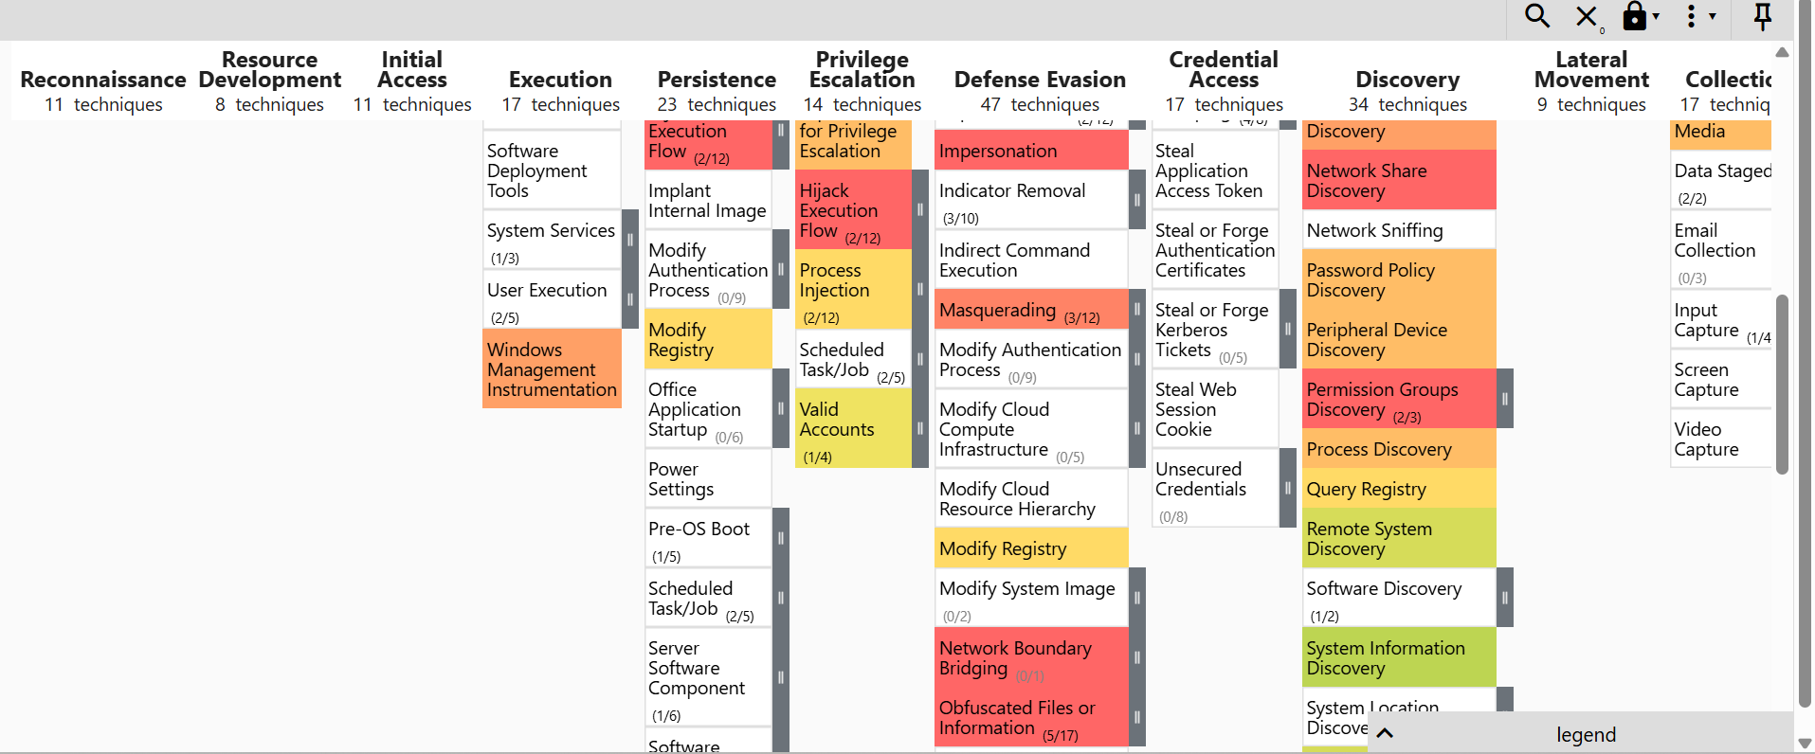
  - Noted: common techniques across multiple APTs, such as:
  - T1566 – Phishing
  - T1078 – Valid Accounts
  - T1059 – Command and Scripting Interpreter
  - T1555 – Credential from stored password
  - T1140 – Deobfuscate/decode file or password.

Findings
- Many healthcare-targeted APTs rely on phishing and valid accounts for initial access.
- Credential dumping and obfuscation are common across groups.
- Persistent techniques like scheduled tasks and remote services are frequently used

